**DOXYGEN**

Doxygen is a documentation generator tool that is widely used in the software development industry. It is designed to extract documentation from source code written in various programming languages, including C++, C, Java, Python, and more. The generated documentation can include details about the code's structure, classes, functions, variables, and their relationships.

**Install Doxygen:**

1. sudo apt-get install doxygen
2. sudo apt-get install doxygen-gui

**Create Documentation in Command Line:**

1. Create a Simple C Program with Doxygen style comments.
2. Create a Doxygen Configuration File (Doxyfile), which contains settings for generating documentation.

Doxygen -g Doxyfile

1. Customize Doxygen Configuration File in a text editor.
2. Generate Documentation

With command:

doxygen Doxyfile

1. View the Documentation  
   Open the generated documentation in a web browser.  
   xdg-open html/index.html

**Create Documentation in Doxywizard:**

Wizard->Project

Check the Scan recursively button to make Doxygen search all the subfolders too.

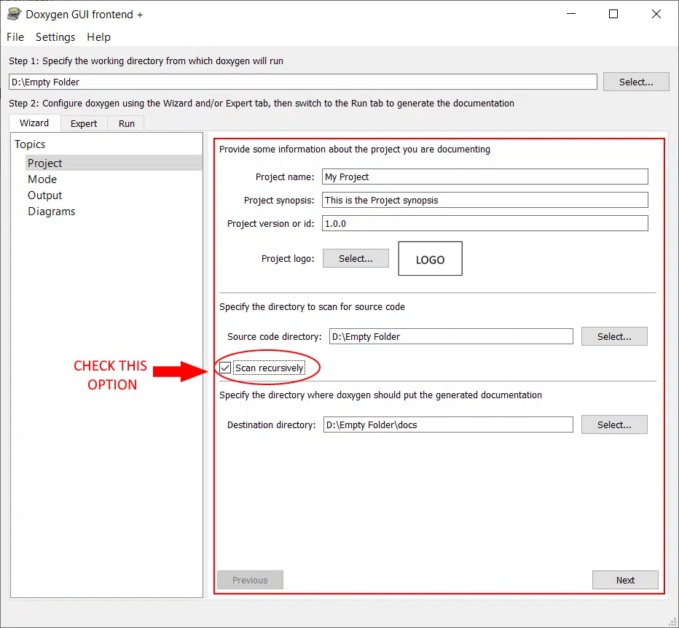

Wizard->Mode

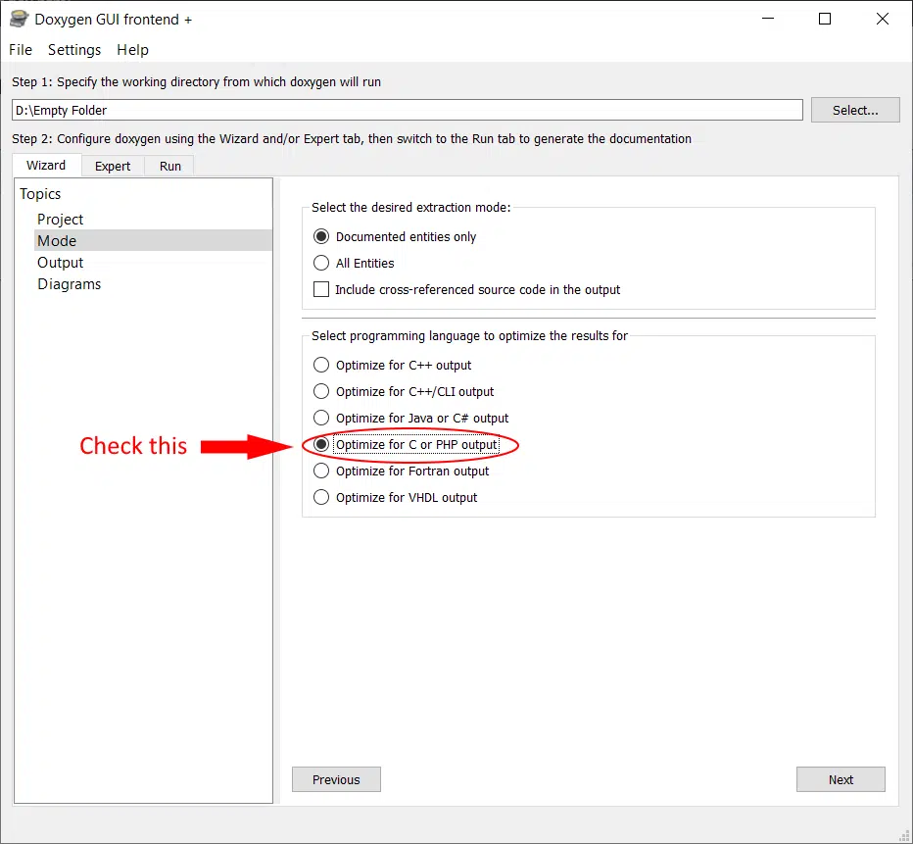

Wizard->Output

For just HTML output uncheck Latex

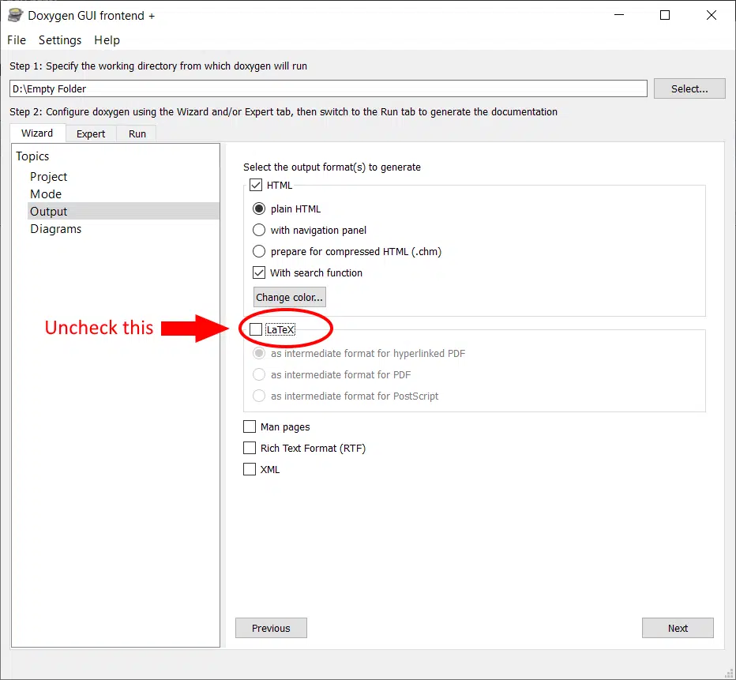

Expert->Project

JAVADOC_AUTOBRIEF is checked so that we can separate the brief and detailed description of the entities using a simple period punctuation so that the first sentence is the brief description and all sentences after that are the detailed description part.

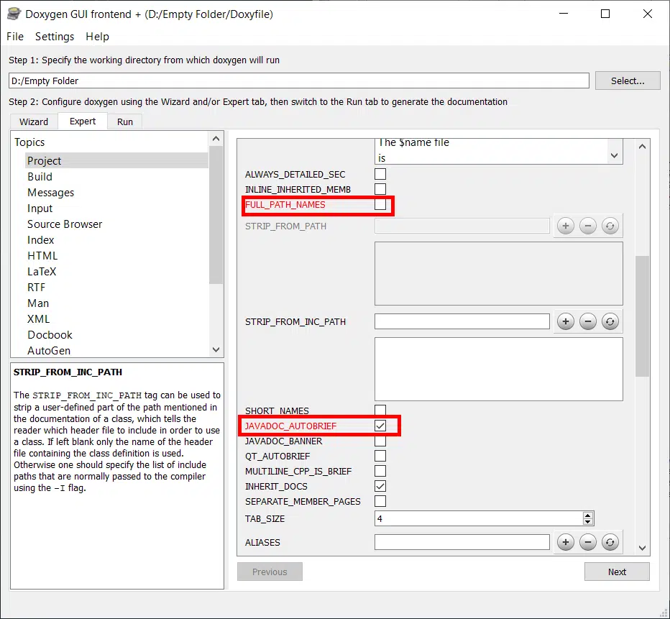

Expert->Build

SHOW_USED_FILES has been unchecked to prevent unnecessary clutter in the documentation. It basically prints a line at the end of pages showing structs the list of files used to generate the documentation.

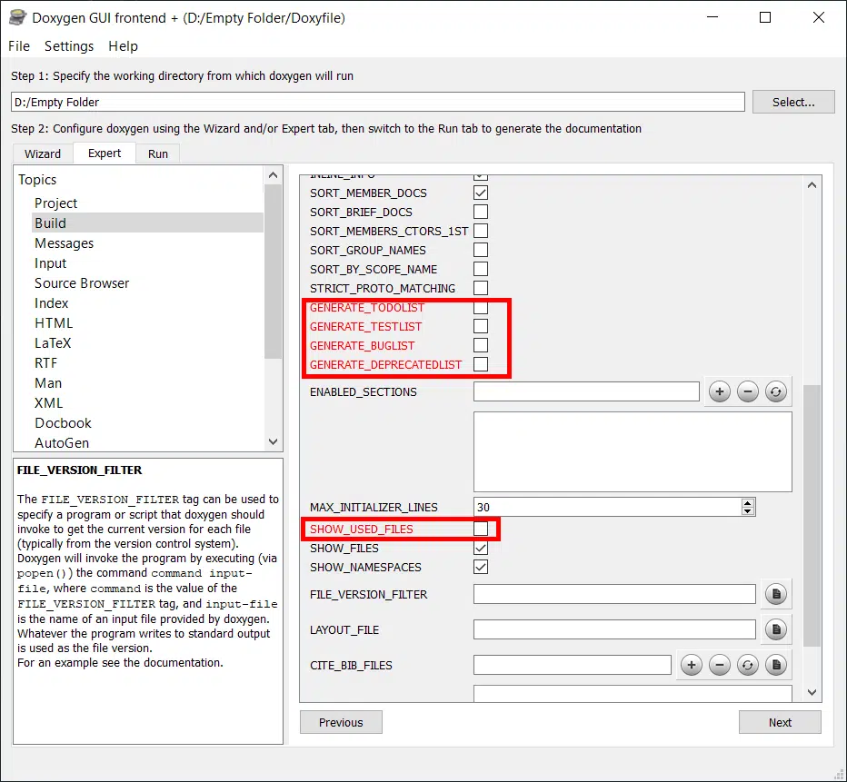

Expert->Input

While writing C code, we often find ourselves using libraries from 3rd parties. These libraries usually contain a large number of files and it might add unnecessary clutter to the documentation. If you have folders that you need to exclude from the documentation, then you can add them to the exclude tab as shown below.

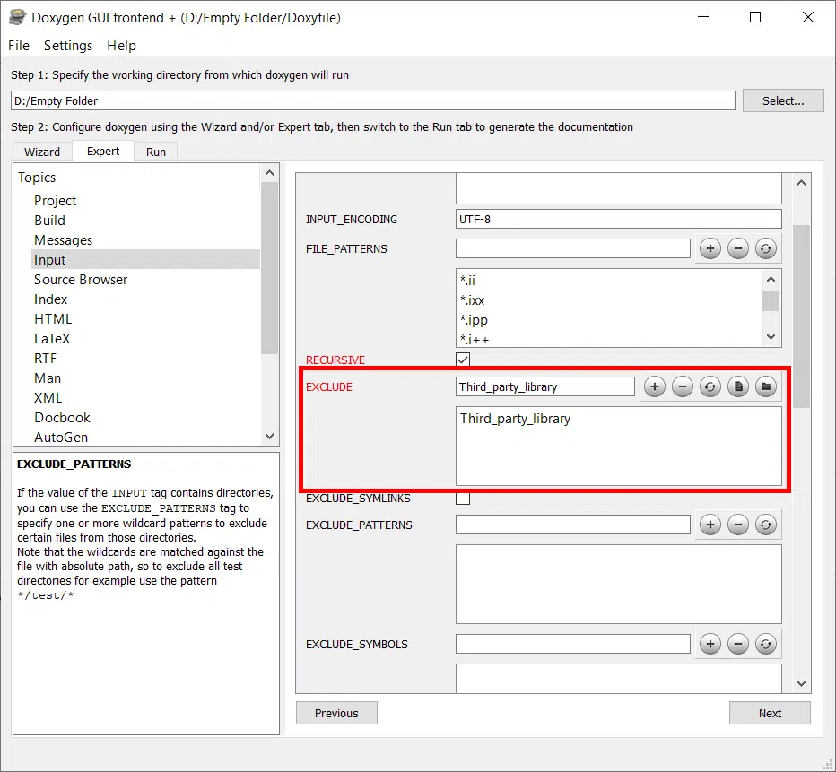

Expert->HTML

Check GENERATE_TREEVIEW option to get the user-friendly left-hand side tree-view

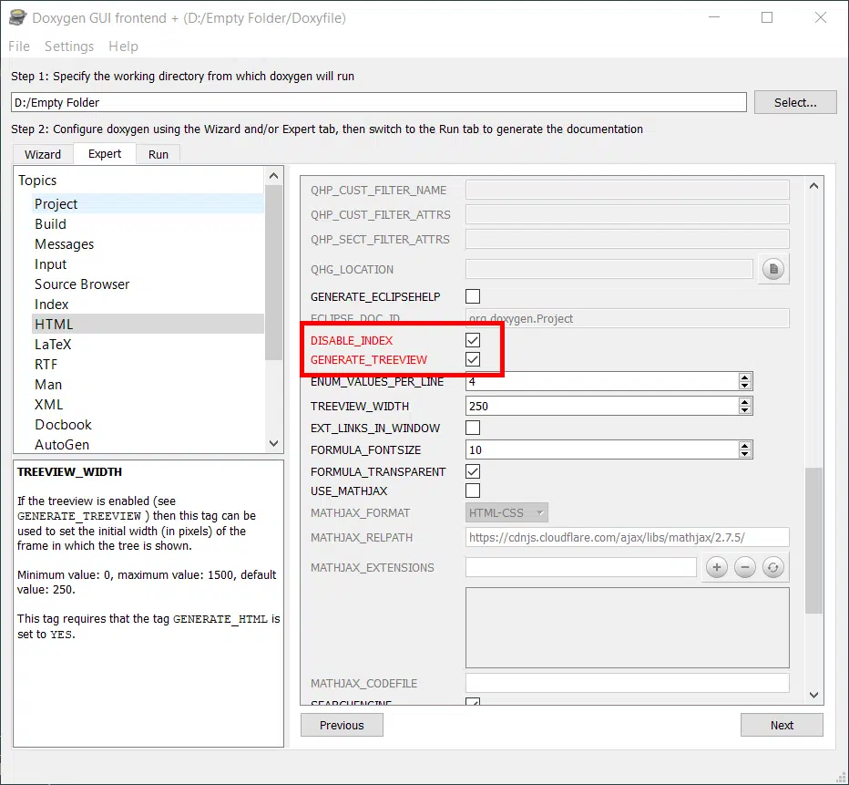

Finally then go to run tab and then run Doxygen

After clicking open HTML output we will be able to see Documentation for our Project.

**Output:**

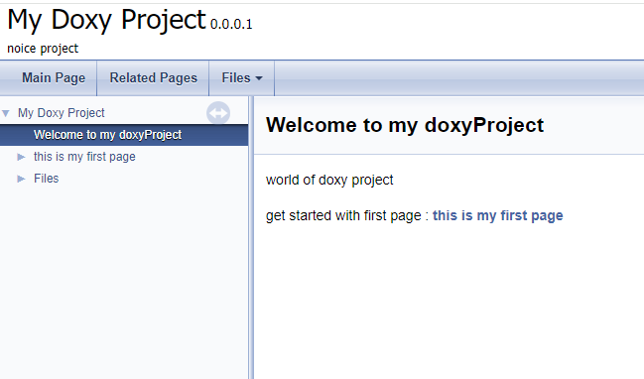

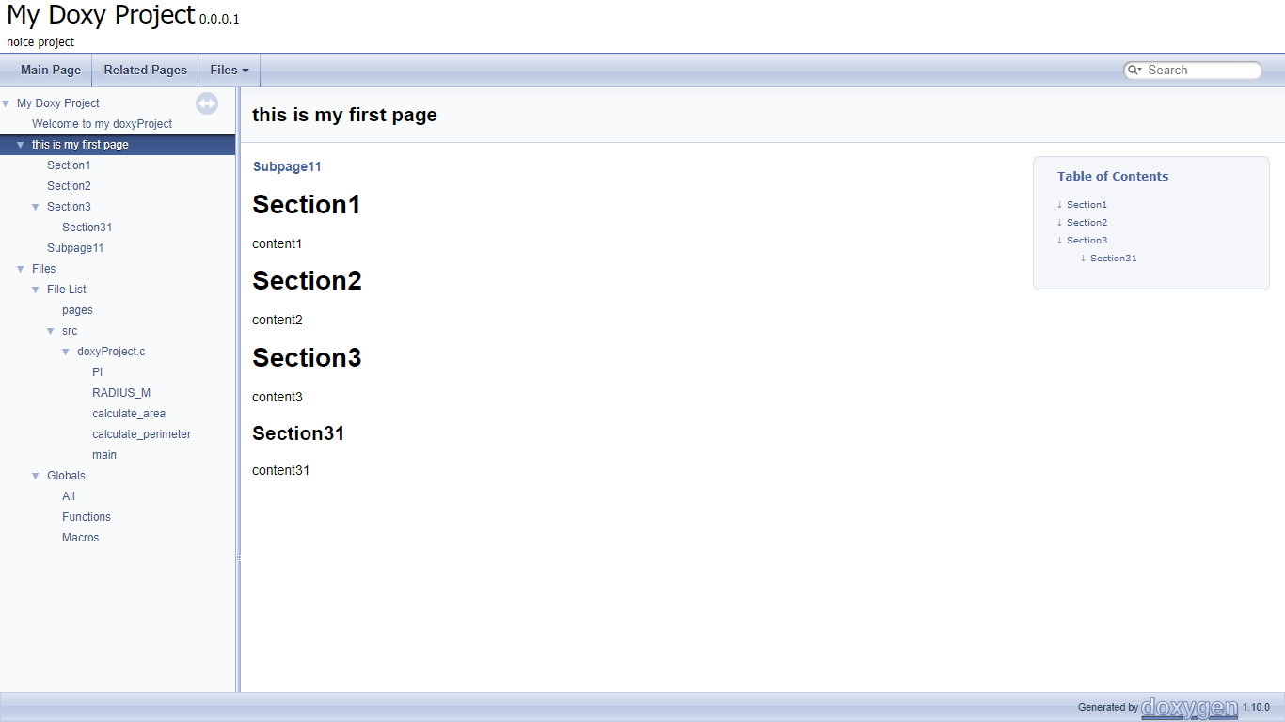

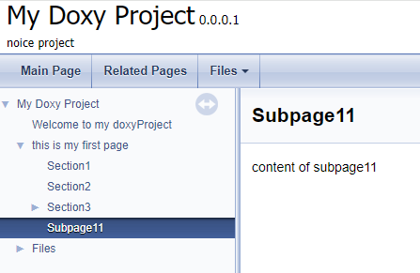

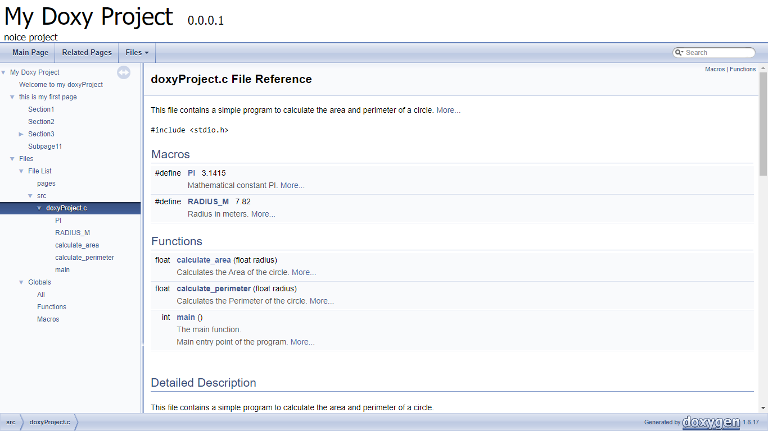

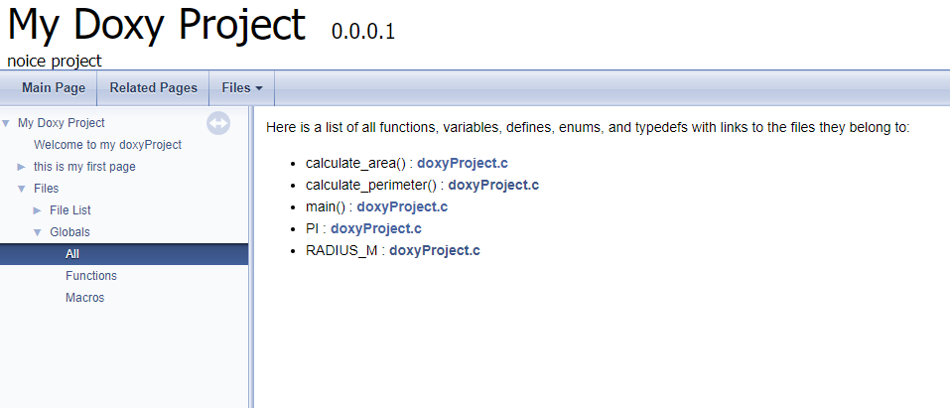

Just for Experiment

